

Billing system

Documentation





**S.I.E.S College of Arts, Science and Commerce**

**Sion(W), Mumbai – 400 022.**

Project report on Billing System

Prof. In-Charge

**Prof. Name**

**(Subject)**

Examination Date:

Examiner’s Signature & Date:

/ / 20

Head of the Department

**Prof. Manoj Singh**

College Seal

And

Date

**GROUP ASSOCIATES**

* STEBIN STAIN PUTHUR – TCS2021074
* RAMKUMAR RAMAKRISHNAN –TCS2021075
* REMMINGLIN MICHAEL – TCS2021077

**ACKNOWLEDGEMENT**

In performing our project, we had to take the help and guideline of some respected persons, who deserve our greatest gratitude. The completion of this project gives us much pleasure. We would like to show our gratitude to **PROF. MANOJ SINGH** for giving us a good guideline for project throughout numerous consultations. We would also like to expand our deepest gratitude to all those who have directly and indirectly guided us in making this project. Many people, especially our classmates and team members itself, have made valuable comment and suggestions on this proposal which gave us an inspiration to improve our project. We thank all the people for their help directly and indirectly to complete our project.

**INTRODUCTION**

The project is on store billing system. Stores/Shops is a place where customers come to purchase their daily using products and pay for that. So, there is a need to calculate how many products are sold and to generate the bills for the customers. In our project we have 2 users. First is the Admin who can add/remove products to/from the inventory, can see the sales and can see the report of any product. Secondly is the cashier who will calculate the bill and print/send a SMS to the respective customer.

**OBJECTIVE**

To make the software fast in processing, with good user interface and it should be used for a long time without error and maintenance.

**WORK FLOW**

**Work in the stores will be done in the following way:**

1. The product will come in the store.

2. The admin will enter the information of the product in database.

3. The customers will come and purchase the required products.

4. The cashier will check the products with the bar code/product id and the bill will be calculated and the final bill will be given to the customer.

5. Customer will pay for the products.

**MODULES**

**We will have 3 main modules in this project. These are as follows:**

* Login – this module is made for the login of users of the software like Admin and cashier.
* Admin – this is the admin module where admin can add/remove cashier, update stock, check sales, etc.
* Cashier – this is the cashier module where cashier will do the billing, check products, etc.

**SDLC MODEL**

**AGILE MODEL:**

The meaning of Agile is swift or versatile. "Agile process model" refers to a software development approach based on iterative development. Agile methods break tasks into smaller iterations, or parts do not directly involve long term planning. The project scope and requirements are laid down at the beginning of the development process. Plans regarding the number of iterations, the duration and the scope of each iteration are clearly defined in advance.

Each iteration is considered as a short time "frame" in the Agile process model, which typically lasts from one to four weeks. The division of the entire project into smaller parts helps to minimize the project risk and to reduce the overall project delivery time requirements. Each iteration involves a team working through a full software development life cycle including planning, requirements analysis, design, coding, and testing before a working product is demonstrated to the client.

**SCOPE**

* Calculate the bills.
* Store how many products are sold.
* Store products and their prices with other information.
* Can see the report of the product in a fixed period of time.

**LIMITATIONS**

* Sales module – which checks the sales of products.
* Barcode scanner – scanning the barcode of the products.
* SMS module – SMS system which sends the bill to the corresponding customers contact number.
* Refund module.

**PROPOSED SYSTEM**

The Billing System is to be computerized in order to overcome the platforms which affects the existing manual system. In the new computerized system, the basic and the initial first step is to ask for a specific user login name and password for it. Thus, it can also take care of data security, now after when the user enters the necessary details in the login name and password it checks for the credentials and allows the user of the system to enter the main page.

**SOME OF THE FEATURES**

* To provide quick and efficient means for performing billing related activities and to effortlessly generate report of the system.
* To automate the work such as billing, Party record, Client record, etc.
* To automate the different types of reports.

**Hardware / Software Requirements**

* Operating system: Windows (7 or 10)
* Ram: 4gb (minimum)
* Storage: 500 gb
* Processor: i3 (minimum)
* Visual studio (2019)
* Microsoft Sql Server (2019)

**Frontend**

* C#

**Backend**

* Mysql

**ADVANTAGES**

* It offers a Paperless mode of transaction.
* It reduces much human efforts in calculating bills.
* It provides accurate and Faultless bill calculations.
* It is flexible and user-friendly.
* It creates transparency if a customer has some doubt regarding the billing.
* Lastly, it saves time.

**DISADVANTAGES**

* It Requires large database or a storage unit.
* It is difficult to store the user data securely.
* It will be costly.
* Undelivered invoice because sometimes electronic invoices are flagged by email services as spam.

**FUNCTION POINT ANALYSIS**

* **LOGIN PAGE:**

EI = 3 (username(A), password(A), login(C))

EO = 2 (after login screen of admin or cashier(A))

ILF = 1 (login details table(A))

* **ADMIN PAGE:**

1. Add cashier

EI = 5 (add cashier btn click(S), name(S), phone no.(S), email-id(S), update btn click(S))

EO = 2 (add cashier page(S), add to table(S))

EQ = 1 (successful prompt(S))

ILF = 1 (cashier details table(A))

1. Delete cashier

EI = 3 (delete cashier btn click(S), cashier id(S), remove(S))  
EO = 2 (delete cashier page(A), delete from table(A))  
EQ = 2 (delete prompt(S), not found prompt(S))  
ILF = 1 (cashier details table(A))

1. Inventory

EI = 3 (inventory click(S), product id(S), search(C))  
EO = 2 (inventory page(A), remaining stock(A))  
ILF = 1 (products table(A))

1. Add products

EI = 6 (add product btn click(S), product id(S), product name(S), quantity(S), cost(S), update(C))  
EO = 2 (add product page(A), update(A))  
EQ = 1 (update prompt(S))  
ILF = 1 (products table(C))

1. Bills

EI = 4 (bills click(S), bill id(S), date(S), search(A))  
EO = 2 (bills page(S), corresponding bill(C))  
EQ = 1 (bill not found prompt(S))  
ILF = 1 (bills table(A))

1. Sales

EI = 4 (sales btn click(S), product id(S), date(A), search(C))  
EO = 2 (sales page(A), corresponding product’s sales(C))  
EQ = 1 (product not found prompt(S))  
ILF = 1 (sales table(A))

1. Logout

EI = 1 (logout btn click(S))  
EO = 1 (logged out(S))  
EQ = 1 (logout prompt(S))

* **CASHIER PAGE:**

1. Billing

EI = 5 (billing click(S), product id(S), quantity(S), customer name(S), phone no.(S))  
EO = 5 (billing page(S), quantity(S), product name(A), cost according to quantity(A), total(A))  
ILF = 1 (products table(A))

1. Print bill

EI = 3 (print bill btn click(S), cash received(A), print(C))  
EO = 4 (print bill page(S), remaining cash(A), save to table(C), printed bill(C))  
ILF = 1 (bills table(A))  
EIF = 1 (connect to printer(C))

1. Inventory

EI = 3 (inventory click(S), product id(S), search(C))  
EO = 2 (inventory page(A), remaining stock(A))  
ILF = 1 (products table(A))

1. Logout

EI = 1 (logout btn click(S))  
EO = 1 (logged out(S))  
EQ = 1 (logout prompt(S))

**TOTAL:**

|  |  |  |  |  |
| --- | --- | --- | --- | --- |
|  | **SIMPLE** | **AVERAGE** | **COMPLEX** | **TOTAL** |
| **EI** | 30 | 5 | 6 | 41 |
| **EO** | 8 | 15 | 4 | 27 |
| **EQ** | 8 | 0 | 0 | 8 |
| **ILF** | 0 | 9 | 1 | 10 |
| **EIF** | 0 | 0 | 1 | 1 |

EI = 41  
 EO = 27  
 EQ = 8  
 ILF = 10  
 EIF = 1

**Fi** = 5+3+1+2+3+0+0+0+3+3+4+2+2+4  
 = 32

**COUNT TOTAL** = 420

**FP** = COUNT TOTAL * (0.65 + 0.01 * Fi)  
 = 420 * (0.65 + 0.01 * 32)  
 = 420 * (0.65 + 0.32)  
 = 420 * 0.97  
 = 407.4

**LINE OF CODE (LOC)**

|  |  |
| --- | --- |
| **HUMAN FACTORS** | **TECHNICAL FACTORS** |
| * Knowledge and testing experience with the project technology | * Availability of ready-to-use tools |
| * Domain area knowledge | * Readiness of test environment and test data |
| * Buffer time for accidents and emergencies | * Availability of open-source or third-party tools and libraries |
| * Time for team communication | * Internal product quality(code, instruments, specifications) |

Loc = (0 + P + (4*R)) / 6

Where O is Optimistic

P is Pessimistic

R is Realistic

**Note:** Values are assumed and not accurate.

|  |  |  |  |
| --- | --- | --- | --- |
|  | **Optimistic** | **Pessimistic** | **Realistic** |
| **Login module** | 100 | 200 | 180 |
| **Admin module** | 200 | 350 | 300 |
| **Cashier module** | 250 | 300 | 200 |
| **Billing module** | 200 | 400 | 250 |
| **Total** | 750 | 1250 | 930 |

Loc = (750+1250+(4*930)) / 6

= (2000 + 3720) / 6

= 5720 / 6

= 953.33

**DATABASE TABLES**

* Customer database table

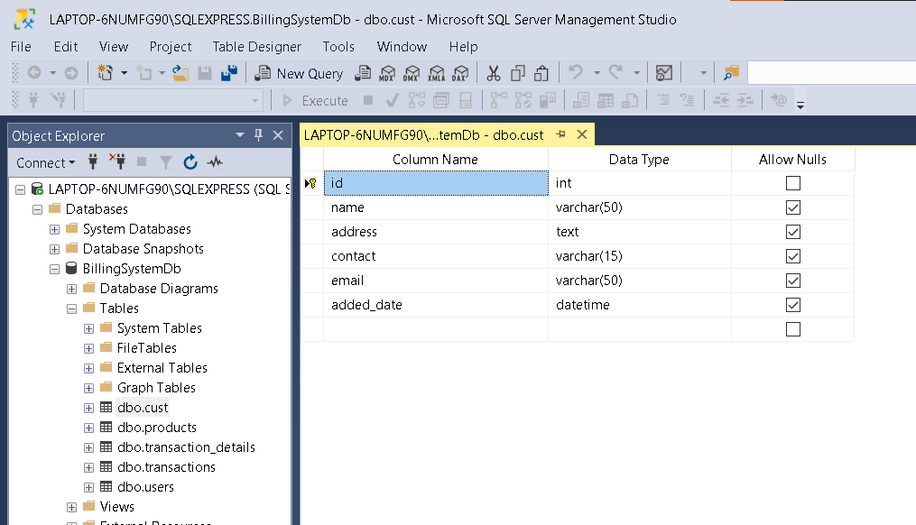

* Products database table

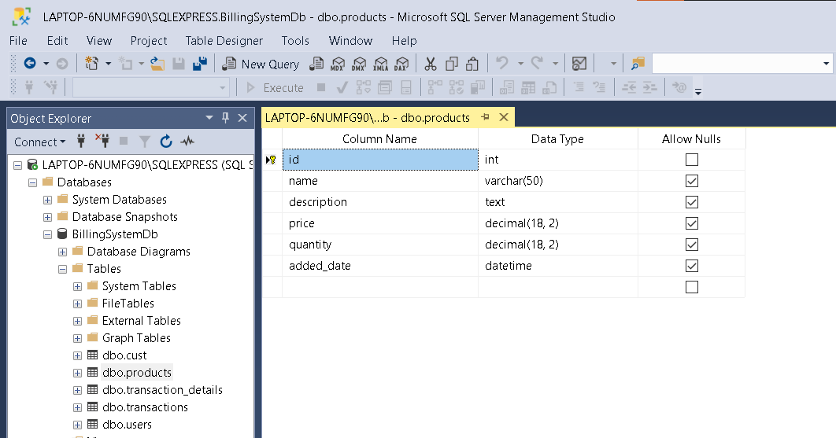

* Transaction details database table

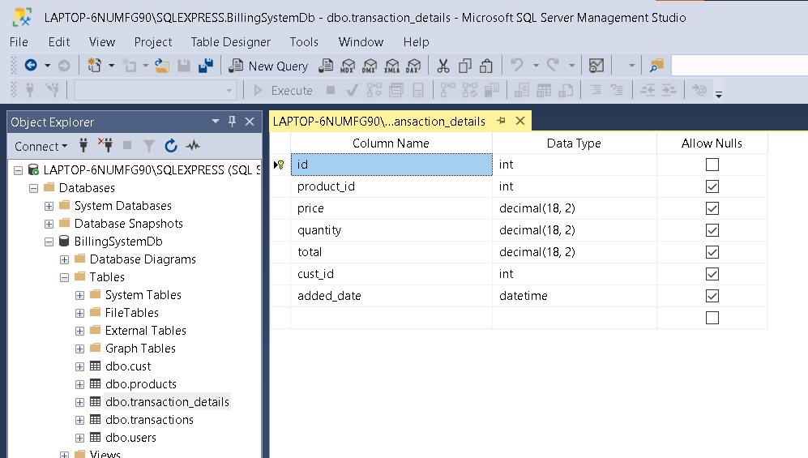

* Transactions database table

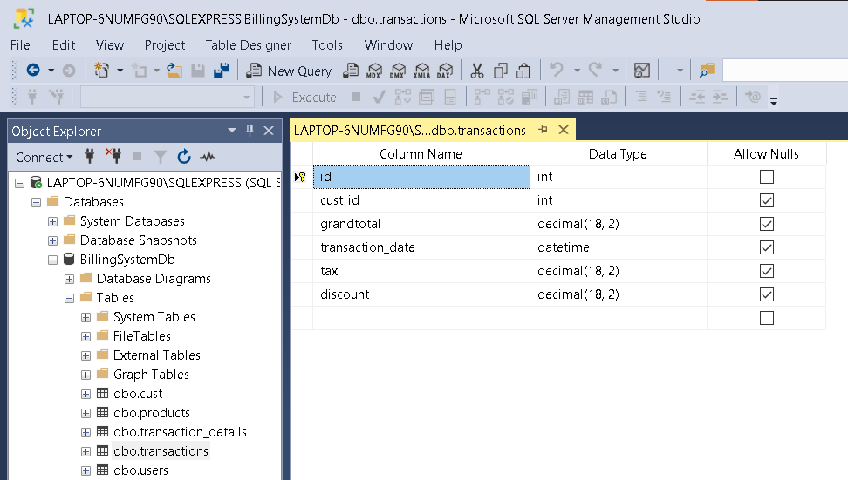

* Users database table

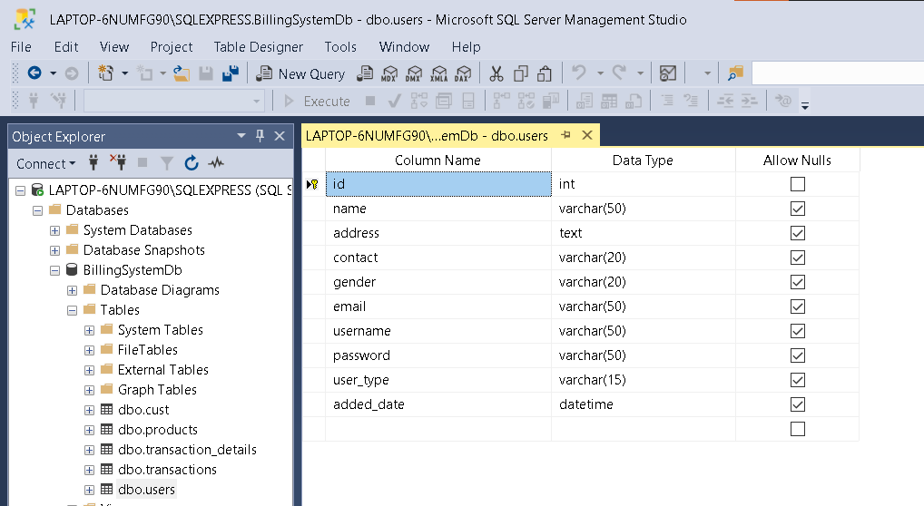

**EVENTS TABLE**

* **ADMIN**

|  |  |  |  |  |  |  |
| --- | --- | --- | --- | --- | --- | --- |
| **Sr no.** | **Events** | **Trigger** | **Source** | **Activity** | **Response** | **Dest** |
| 1 | Log in | Login page | Admin | Enters username and password | Log in successful or not | Admin |
| 2 | Add cashier | Add a new Cashier | Admin | Enters cashier details | Auto generates cashier id and password | Admin |
| 3 | View cashier | Viewing cashier | Admin | Enter cashier id | System shows cashier details | Admin |
| 4 | Update cashier | Updating cashier | Admin | Enters new details | Update successful or not | Admin |
| 5 | Remove cashier | Removing Cashier | Admin | Removes cashier | Removed Cashier successfully/not | Admin |
| 6 | Add products | Product details | Admin | Enters product details | Update successful or not | Admin |
| 7 | View products | Viewing products | Admin | Enters product id or name | System shows product details | Admin |
| 8 | Update products | Updating products | Admin | Enters new details | Update successful or not | Admin |
| 9 | Delete products | Deleting products | Admin | Removes product | Deletion successful or not | Admin |
| 10 | View bills | Checking bills | Admin | Enters bill id or date | System shows bill details | Admin |
| 11 | Sales per product | Check’s sales report | Admin | Enters product id or date | System shows product sales | Admin |
| 12 | Logout | Logs out | Admin | Log out | Logged out successfully | Admin |

* **CASHIER**

|  |  |  |  |  |  |  |
| --- | --- | --- | --- | --- | --- | --- |
| **Sr no.** | **Events** | **Trigger** | **Source** | **Activity** | **Response** | **Dest** |
| 1 | Log in | Login page | Cashier | Enters username and password | Log in successful or not | Cashier |
| 2 | Billing | Billing page | Cashier | Enters the product id or name | The corresponding product is added in the billing list and the bill is generated | Cashier |
| 3 | Inventory | View inventory | Cashier | View’s inventory | Displays list of products along with details | Cashier |
| 4 | Add customer | Adding customer | Cashier | Enters customer details | Successful or not | Cashier |
| 5 | Update customer | Updating customer | Cashier | Enters new details | Successful or not | Cashier |
| 6 | Delete customer | Deleting customer | Cashier | Deletes customer | Successful or not | Cashier |
| 7 | View bills | Checking bills | Cashier | Enters bill id or date | System shows bill details | Cashier |
| 8 | Logout | Logs out | Cashier | Log out | Logged out successfully | Cashier |

**USE CASE DIAGRAM**

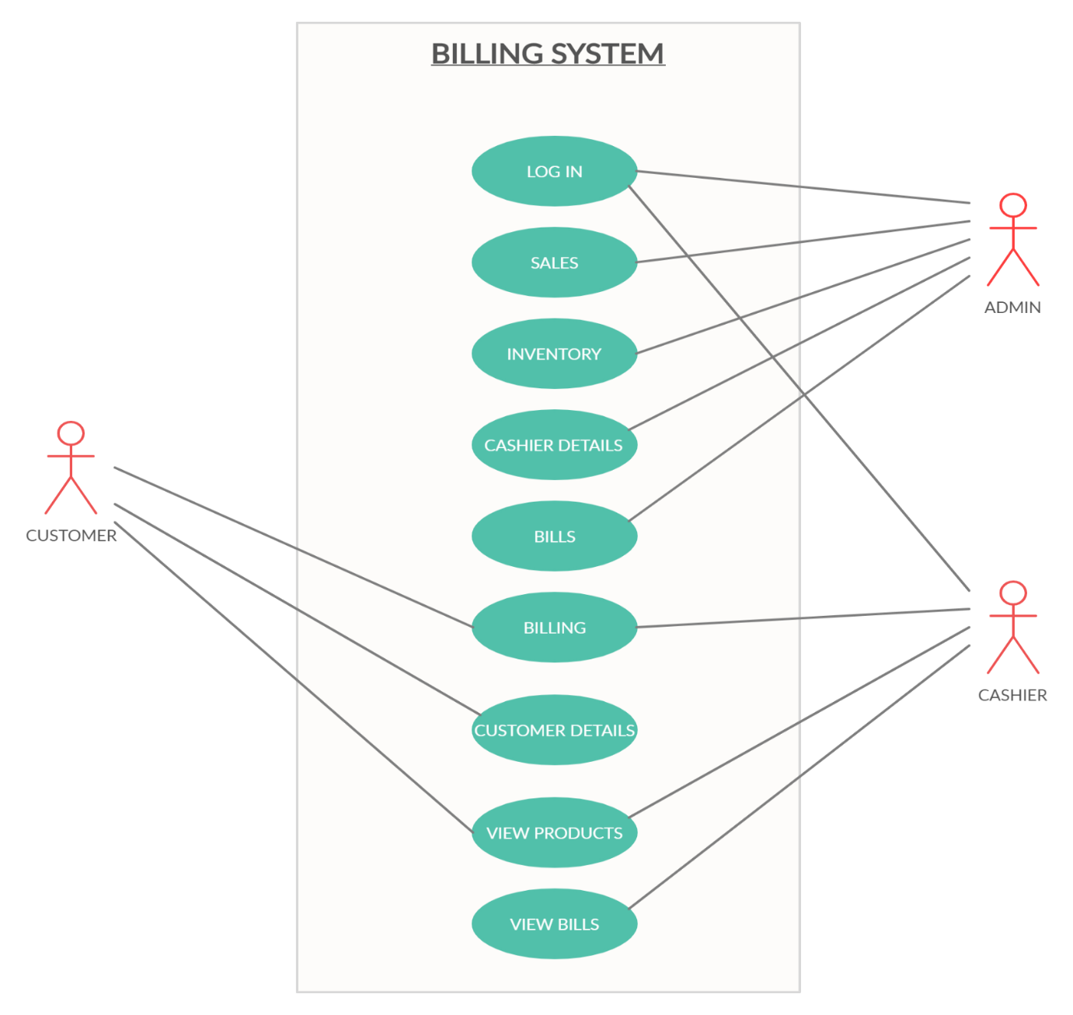

**ER DIAGRAM**

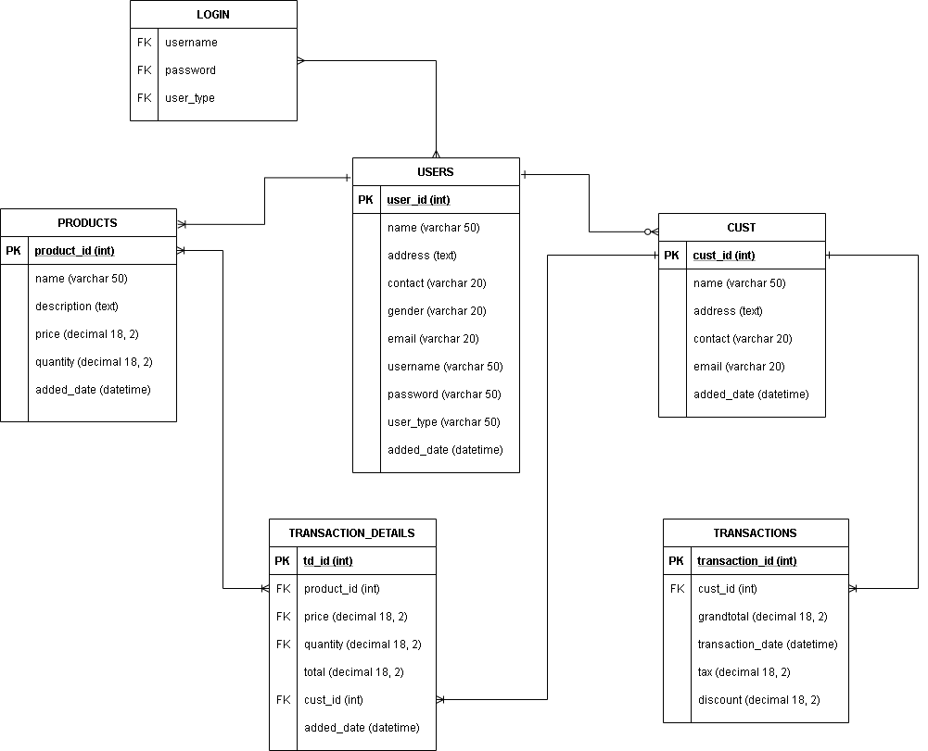

**DATA FLOW DIAGRAM (DFD)**

* **LEVEL 0**

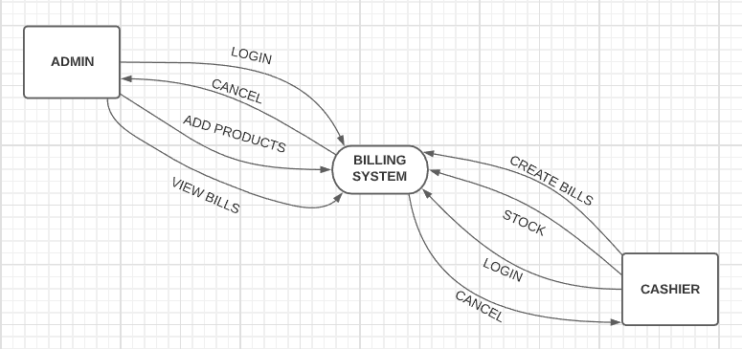

* **LEVEL 1**

**LOGIN**

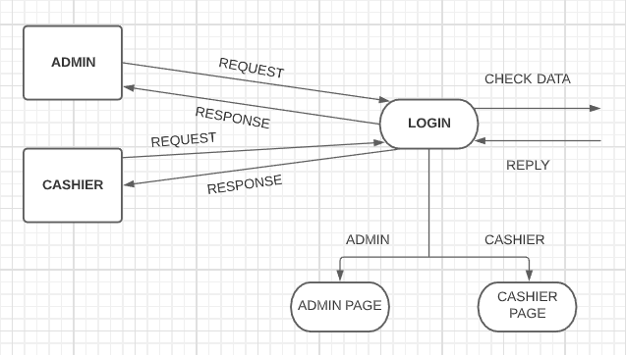

**ADMIN**

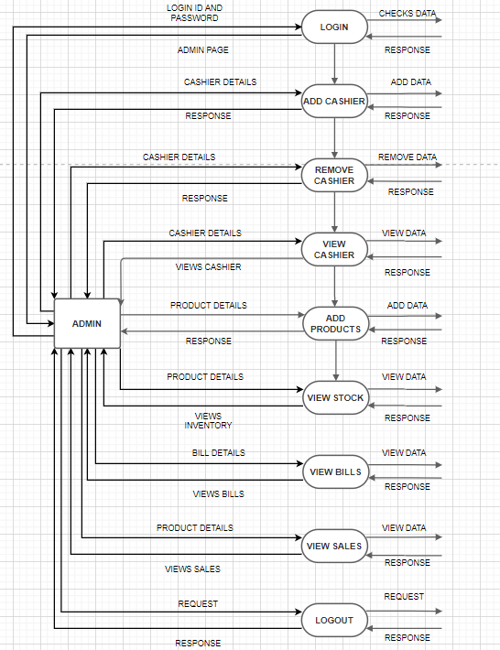

**CASHIER**

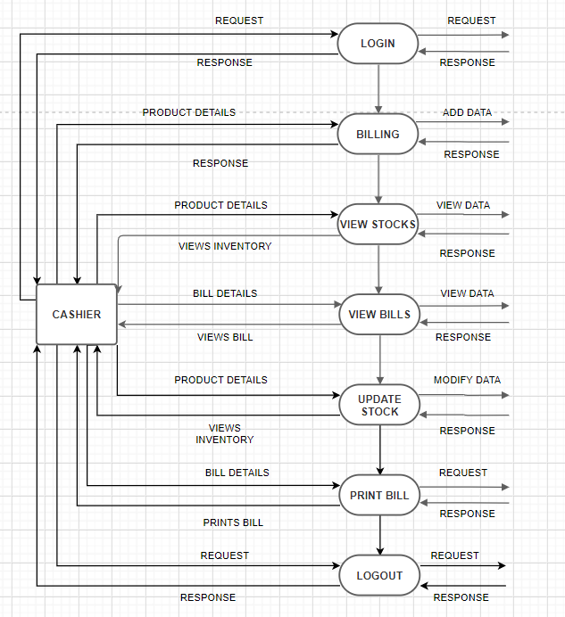

**CLASS DIAGRAM**

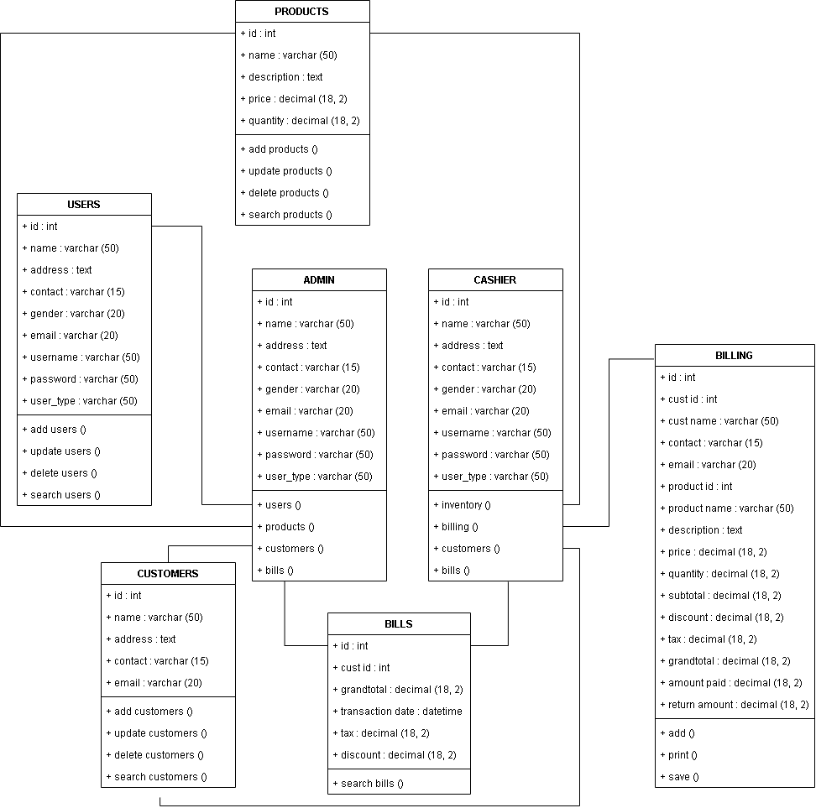

**ACTIVITY DIAGRAM**

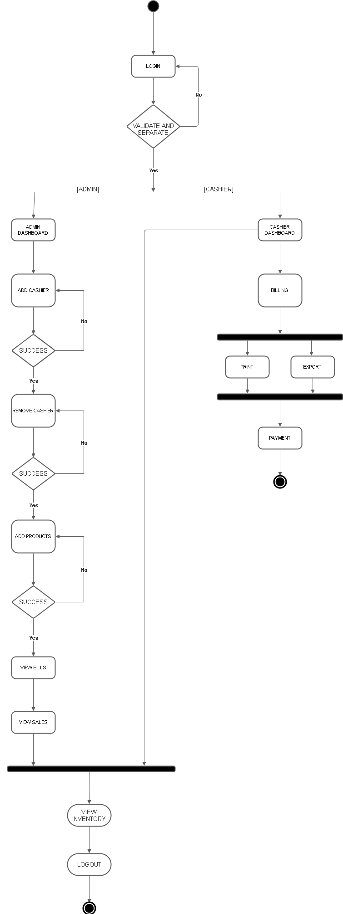

**DEPLOYMENT DIAGRAM**

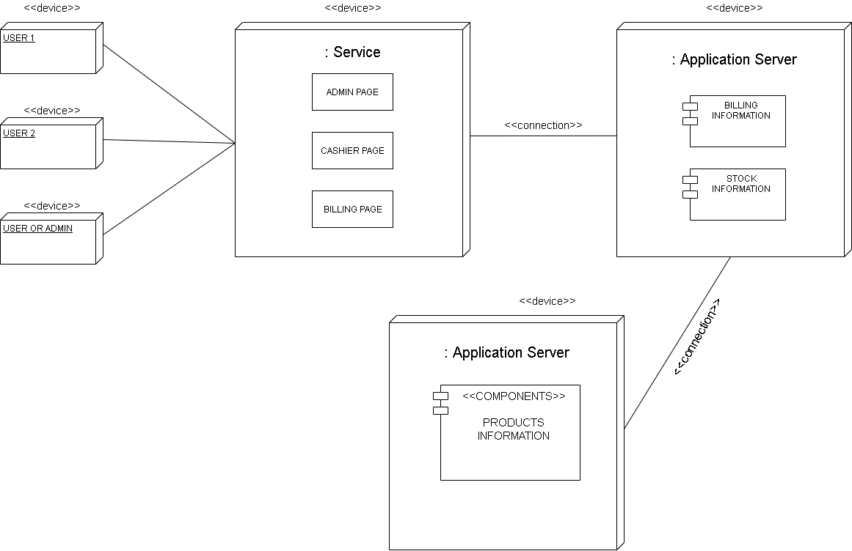

**SEQUENCE DIAGRAM**

* **Admin**

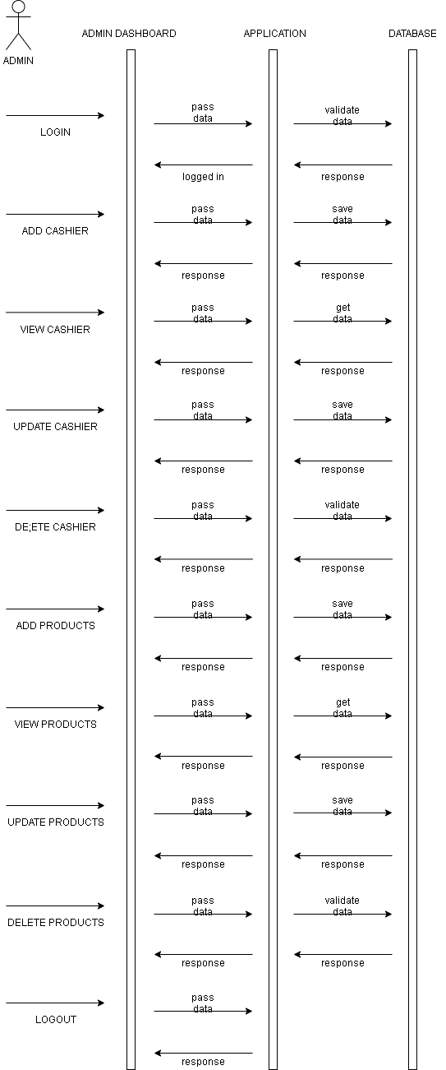

* **Cashier**

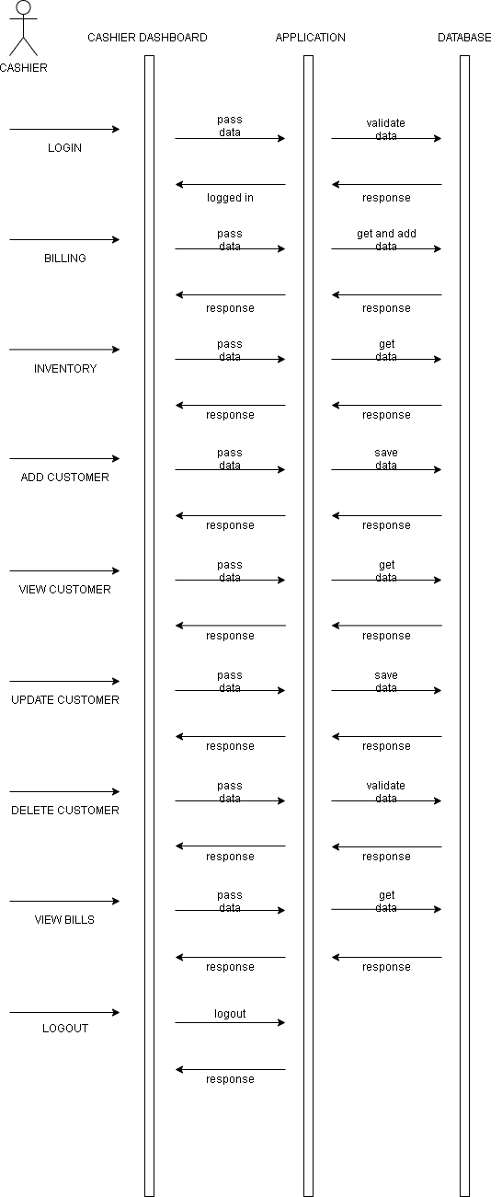

**FUTURE ENHANCEMENTS**

**Features to be added in the future:**

* After saving the bill an SMS with the bill should sent to the customer’s mobile number.
* Sales module to check the sales of the products sold.
* Barcode scanning of products as currently the products are added using product id or name.
* Refund module.

**REFERENCES**

1. Google
2. YouTube